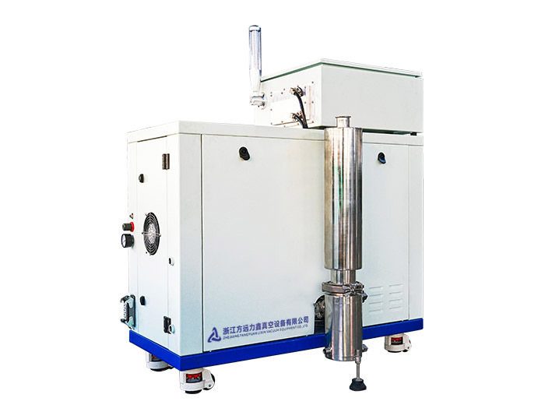

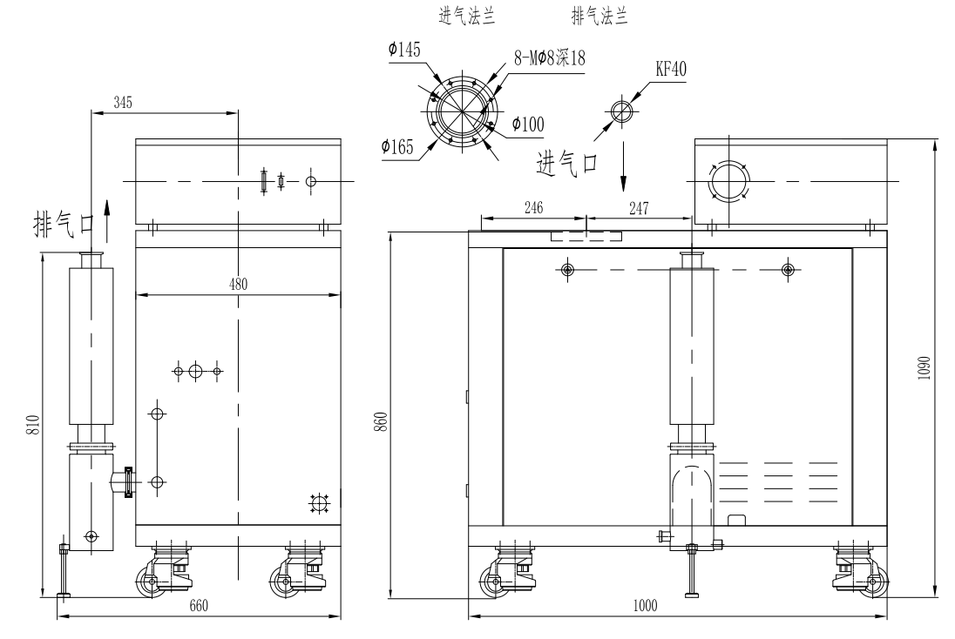

The single crystal unit is an oil-free vacuum unit composed of Roots vacuum pump as the main pump and screw vacuum pump as the front pump in series. The unit has high vacuum degree, wide working pressure range, high pumping efficiency, overall box-type outsourcing of the unit, and the unit adopts intelligent frequency conversion control system, which can start quickly, can control the unit performance in real time according to production requirements, improve production stability and meet customer needs. The vacuum pumps used by the unit are not sensitive to a small amount of dust and have obvious advantages in applications containing a small amount of dust. The motors used by the unit are water-cooled motors with good heat dissipation effect and can avoid motor fan dust. They are especially suitable for monocrystalline silicon production process in photovoltaic solar energy industry and can meet the production needs of lithium battery, semiconductor and other industries.

